Week 1 – 2:

--Overview of C, Constant, Variable and Data Types

ROLL NO.:241501202

Name: SHRIVISHAL Sv

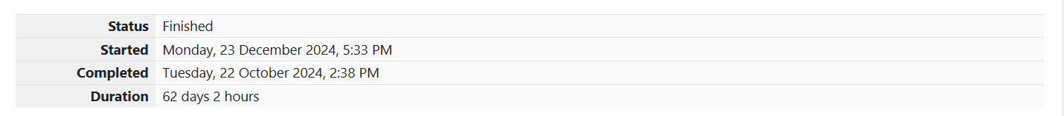

Q1) Write a program to input a name (as a single character) and marks of three tests as m1,

m2, and m3 of a student considering all the three marks have been given in integer format.

Now, you need to calculate the average of the given marks and print it along with the name

as mentioned in the output format section.

All the test marks are in integers and hence calculate the average in integer as well. That

is, you need to print the integer part of the average only and neglect the decimal part.

Input Format :

Line 1 : Name(Single character)

Line 2 : Marks scored in the 3 tests separated by single space.

Output Format:

First line of output prints the name of the student. Second line of the output prints the

average mark.

Constraints

Marks for each student lie in the range 0 to 100 (both inclusive)

Sample Input 1 :

A

3 4 6

Sample Output 1 :

A

4

Code:

OUTPUT:

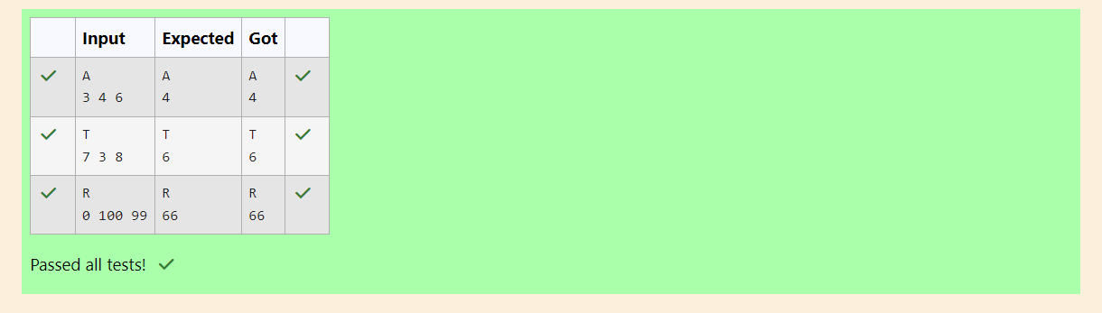

Q2) Some C data types, their format specifiers, and their most common bit widths are as

follows:

• Int ("%d"): 32 Bit integer

• Long ("%ld"): 64 bit integer

• Char ("%c"): Character type

• Float ("%f"): 32 bit real value

• Double ("%lf"): 64 bit real value

Reading

To read a data type, use the following syntax:

scanf("`format_specifier`", &val)

For example, to read a character followed by a double:

char ch;

double d;

scanf("%c %lf", &ch, &d);

For the moment, we can ignore the spacing between format specifiers.

**Printing**

To print a data type, use the following syntax: printf("`format_specifier`", val)

For example, to print a character followed by a double:

char ch = 'd';

double d = 234.432;

printf("%c %lf", ch, d);

**Note:** You can also use cin and cout instead of scanf and printf; however, if you are taking

a million numbers as input and printing a million lines, it is faster to use scanf and printf.

**Input Format**

Input consists of the following space-separated values: int, long, char, float, and double,

respectively.

**Output Format**

Print each element on a new line in the same order it was received as input. Note that the

floating-point value should be correct up to 3 decimal places and the double to 9 decimal

places.

**Sample Input**

3

12345678912345

a

334.23

14049.30493

**Sample Output**

3

12345678912345

a

334.230

14049.304930000

**Code:**

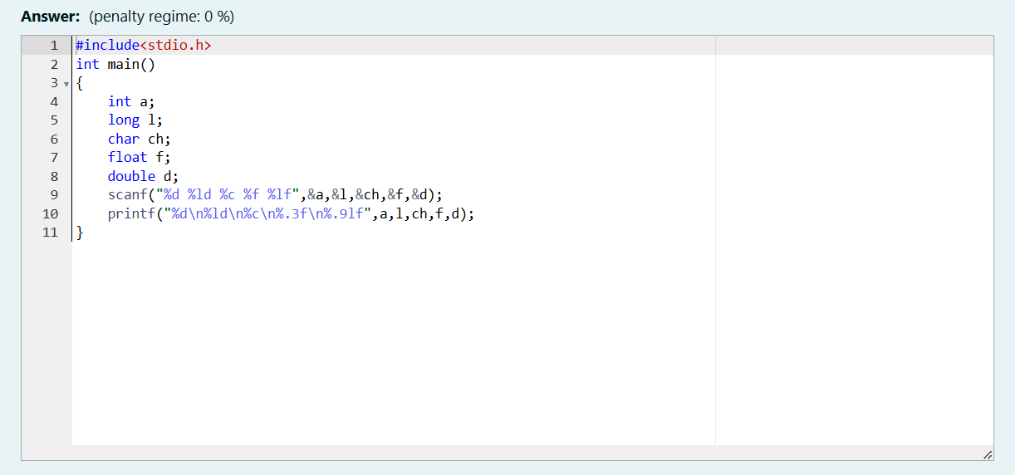

OUTPUT:

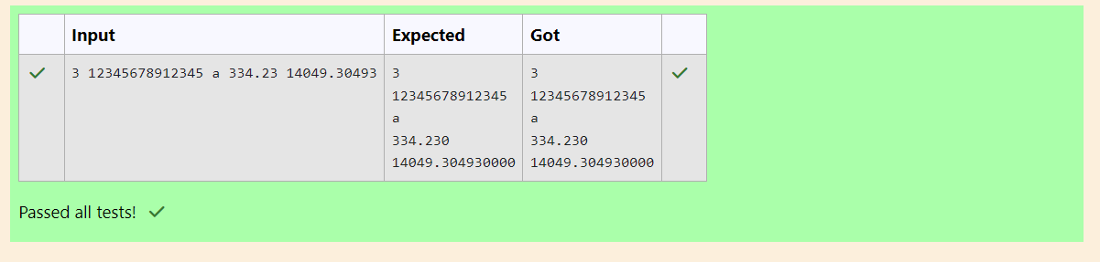

Q3) Write a program to print the ASCII value and the two adjacent characters of the given

character.

**Input**:

E

**Output:**

69

D F

**Code**:

OUTPUT:

